Effective index method

Q:How to solve a TM0 mode of a rib waveguide?

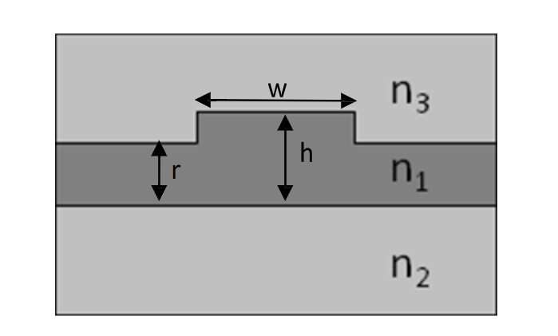

A:Divide the rib waveguide in three region, and then use Effective index method

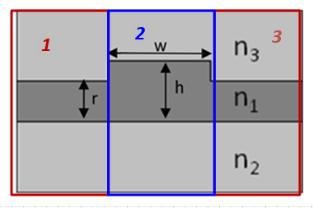

***Step 1***: solve the TM0 mode of a slab waveguide of width r

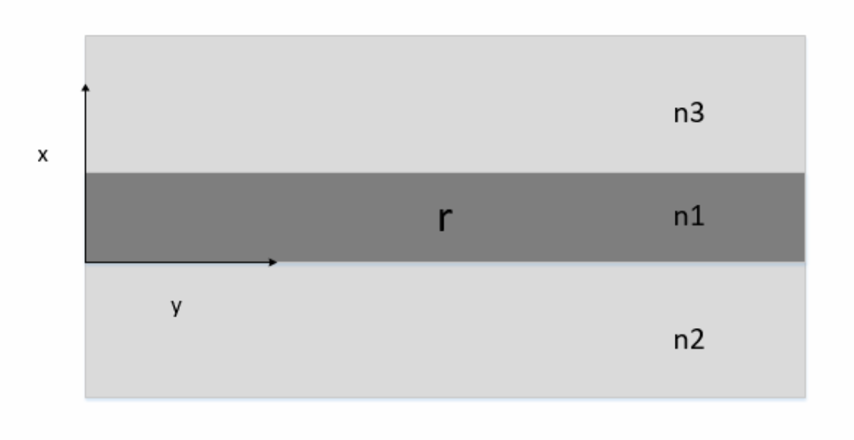

For TM mode,  ,for planar waveguide  applying these two condition we get the eigenfunction of 



For every guide modes, their distribution in region n2 and n3 must be decayed, and the distribution in n1 must be confined, therefore we guess the general solutions should be as:



Where  , ,

Since we solve TM mode,  and  which corresponds to  should be continues on upper and lower boundary. Then apply totally 4 boundary conditions on interface  and  , we can obtain the eigenfunction of TM mode:



Where  is the order of mode. For TM0 mode,  , then we have the eigenfunction of TM0 mode:



This is a transcendental equation which is hard to solve manually. Therefore, I solve it by MATLAB. And the result was shown to be:



This effective index was considered to be the cladding index of region 2.

***Step 2***: solve the TM0 mode of a slab waveguide of width h

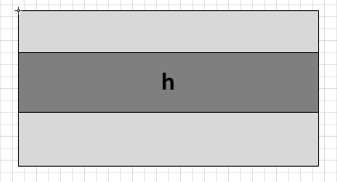

The process is all the same as step 1 except substituting h for r. Similarly, I got the result:



This effective index was considered to be the core index of region 2.

***Step 3***: solve the TE0 mode of a slab waveguide of width W

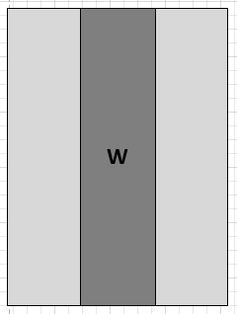

For TE mode,  ,for planar waveguide  applying these two condition we get the eigenfunction of 



For TE mode, the

The boundary condition of TE mode is slightly different from that of TM mode. For TE mode,  and  which corresponds to  should be continuous at each boundary. Similarly, by applying the total 4 boundary conditions, the eigenfunction of TE mode should be:



For TE0 mode,  , then we have the eigenfunction of TE0 mode:



I solve this equation by MATLAB and get the result as:



Therefore, the final result, the effective index of TM0 mode of rib waveguide should be 3.4943. The result obtained from Lumerical is 3.46937, so the error is approximately 0.7%.